**Title of the communication, Times New Roman, 14, bold, centered, line spacing 1.0; maximum two lines**

Name M. Surname1,*,…, Name M. Surnamen (underline the presenting author)

*1Affiliation of first author*

*nAffiliation of nth author*

*\*author@mail.xx* (presenting author email address)

The abstract should be written in English using Times New Roman font, size 11, with single line spacing and with justified format. The maximum length is 1 page. Color figures can be included.

Please submit the abstracts in Microsoft Word format and save the file as: name_surname_poster.doc or name_surname_oral.doc (or docx).

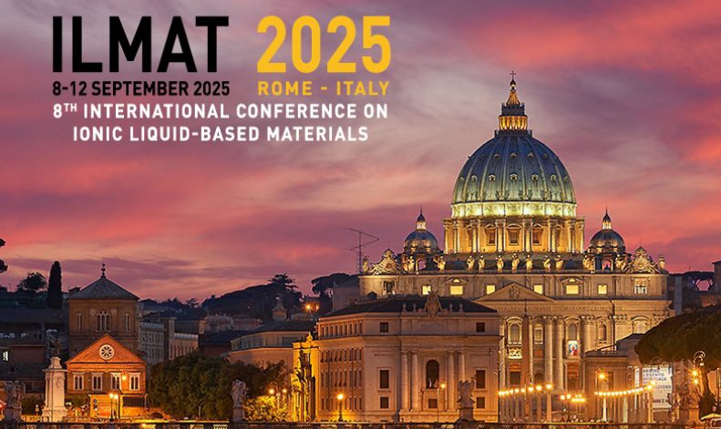

The style for reference is [1].

Figures should be embedded in the main text. Please insert your figure inside the text box.

**Scheme or Figure 1:** Legend here

(Times New Roman, 9, line spacing 1.0, justified)

**Acknowledgements**

(Times New Roman, 10, line spacing 1.0, justified)

**References**

[1] M.J. Earle, K.R. Seddon, Ionic liquids. Green solvents for the future, Pure Appl. Chem. 72 (2000) 1391–1398. https://doi.org/10.1351/pac200072071391.

References should be included in the above indicated format (Times New Roman, 10, line spacing 1.0, justified).